The TVPBC Board Meeting was called to order at 3:30 p.m., November 14, 2023, by Gordon Young, President. In attendance was Gordon Young, Bruce LaCour, Kelly Bryan, Bill Cumbow, and Kathy Parr.
Additional attendees: 6
Minutes for October 10, 2023, Board meeting were approved.
Director reports were as follows:
PRESIDENT – Gordon Young
Courts
Fencing completion is set to begin Wednesday. The courts should be open for play within a week, maybe sooner. The new schedule is prepared and ready for publishing. We should assume Larissa cannot get this in the system until December 1 (she is on vacation and is the lone updater of Schedule POA).

Kahite fencing is not quite what we hoped for, but is still much better than previous temporary courts.

The courts look fabulous.

Election
With Matt Fredericks joining as Training Director candidate we have a full slate of candidates. Under the assumption that there are not going to be others throwing their hats in the ring, we have been working closely with Gary, Don and Matt to ensure a smooth transition.

Bruce, Gary and I will meet with Simon to discuss open issues and also make certain that we have a personal level of contact with Gary as incoming President.

Pickleball Den
There are a number of us working on PD Club implementation. The good news is we can now register online, pay dues, and it works! There will be a lot of work to get this up and running completely, but we are making progress. I will hold a meeting for Pickleball Den 10-noon Thursday, 11/16, to learn the system.

Fundraising
As noted we have a Full Tournament Sponsor, Campbell Financial (no relation to Ben) for the Spring 2024 Tournament. We have also collected commitments from Paddletech and Diadem, so far, regarding donating auction items and balls for use at the tournament.

Special Olympics and our team (joining me is Doug Jobes) will being going after major, platinum sponsors after Thanksgiving.

I am continuing to discuss having a Pro come teach, which would be sponsored. We could also offer additional lessons for a fee. The Rec Department is also requesting 20% fee on top. That continues to be an issue that has not been resolved.

Reopening Party
Rec Department has proposed a reopening party that would extend to a broader community than just TVPBC members. After a brief discussion I discussed with Kelly and sat with Trey and Simon. Conceptually, they would provide hamburger/hot dogs during our November Social. Our only responsibility would be to provide a couple of courts for "non-member" introduction and play. Should be a win-win scenario.

School Program
Bill and Sharon again ran the Steekee Elementary program, and it was again a resounding success. I expect we will continue to expand slightly in the spring.

Key Open Projects
Most of these are tied to discussions with the Rec Department and POA:
- AED
- Covering the bleachers
- Fan(s) for Plex
- Covered benches at Kahite
- CPR classes again in 2024? I do suggest we donate to TV EMS/Fire

VICE PRESIDENT – Bruce La Cour
- “Lobbing for the Library” Championship went well with the weather cooperating. Everyone seemed to enjoy this fund raising, socially competitive event….all for a good cause.
- Participants in the Championship were as follows:
  - 2.5 players -- 12
    - Men – 7
    - Women – 5
  - 3.0 players -- 11
    - Men – 6
    - Women – 5
  - 3.5 players -- 16
    - Men – 7
    - Women – 9
  - 4.0 players -- 14
    - Men – 11
    - Women – 3
- Approximate net proceeds from tournament:
  - Tournament registration fees -- $2900
  - Tournament Expenses – approximately $573.07
    - PayPal fees -- $132.16
    - PB Den fees at $5 per player (53 players) -- $265.00
    - Snacks/Drinks – approximately $167.91
    - Flyers -- $8.00
  - Tournament Net Proceeds -- approximately $2326.93
- Plans and discussions for the 2024 Spring Open Tournament continue
  - Basic flyer with “Save the Date” will go out to various clubs in December
  - Tournament dates of April 26-28, 2024, with After Party April 29, 2024
  - Final flyers & yard signs for both the tournament and the After Party will be developed in January 2024 and posted around pickleball courts, in Wellness Center, Rec Center, at Kahite, TVN Ad, and Tellico Life
  - Mike Peters will advertise over 5 or 6 states for participation
  - Pickleball Den Brackets will be set up in January 2024
  - Registration will open February 1, 2024

SOCIAL – Kelly Bryan
We are anticipating that the courts will be fully available for our November 29th Social. We are having a Holiday/Pickleball sweater contest during this social, awarding medals:
- Most Creative
- Most Festive
- Funniest

More importantly, we are collecting cash/toys for the Immanuel House in Lenoir City. It is a safe house for children removed from their homes due to abuse or neglect. They also provide toys for over 200 children who are low income or in the foster care system. There are 3 ways to help:
- Immanuel House would like a Play Station for kids waiting for their foster placement. This would help calm them after being removed from a traumatic situation. If you are interested in contributing toward this, please write a check to Annie LaCour. If we do not collect enough money for the Play Station and games, we will donate the money directly to Immanuel House. If you do not want to contribute to a Play Station, you can:
- Bring an unwrapped toy for children between the ages of 1 and 14
- Write a check to Loudon Country Baptist Association with Immanuel House in the memo line
Our next event will be the Volunteer Luncheon. I need a complete list of volunteers from each of the board members by December 13th. Please include the volunteer's email address as that is how I will issue invitations. The Luncheon will be held on Saturday, January 27th, from 11-2pm.

Finally, I will be meeting with the Social Committee on January 9th to discuss plans for 2024. If you have any suggestions, please feel free to email them to me or contact anyone on the social committee.

EVALUATIONS – Steve McCormick
October Evaluations
REGULAR EVALUATIONS | CANDIDATES | PASS | FAIL | RETEST | WITH-DRAW
October '23
2.5 to 3.0 | 8 | 6 | 1 | 0 | 1
3.0 to 3.5 | 8 | 6 | 1 | 0 | 1
3.5 to 4.0 | 0 | 0 | 0 | 0
FASTRACK | 2 | 1 | 1
TOTAL | 18 | 13 | 3 |  | 2
EVALUATION REVIEW (6 MONTHS) We had one large session during the eval week and a regular session on the Sat. Results above. Overall for the year, the lower level candidates had a pretty high success rate. 3.5-4.0 candidates didn't fair as well.
So for the season we have an average 72% level up rate.
In comparison, and anecdotally, it's comparable to the prior year’s result of an overall 75% level up rate.
I will hold a team debrief very soon (Nov), and then for the upcoming season, we plan on first of year training again. There are new team members that haven't gone through any formal sessions, so that will fill those gaps. When the debriefing occurs, I'm inviting all board members to also attend as I'm sure you have tidbits that may be helpful to further enhancing the process.
The new schedule will be inclusive of Kahite Fastracking. The sense I get is that many of the players there do not wander up this far. There is a small army that need TVPBC levels, so I've had brief conversations with three folks from Kahite that I will enlist to help with Kahite evals going forward.
FINANCE– Don MacLeod for Karen Birch
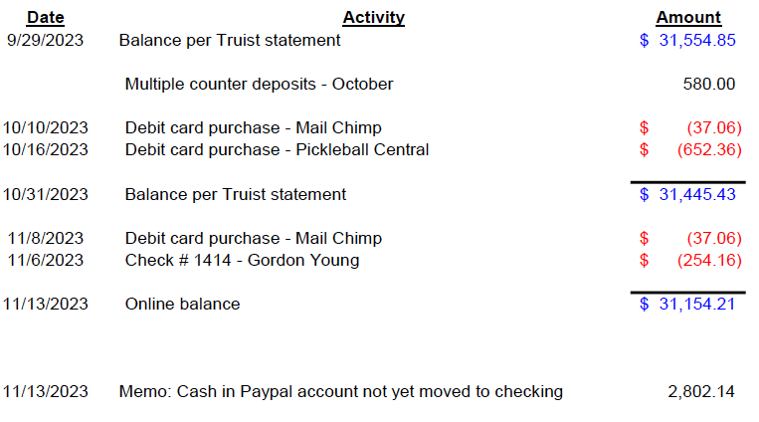
TRAINING-Bill Cumbow
The Skills & Drills program was suspended for court re-surfacing October 2, 2023, and is determined to be complete for the 2023 season. The S&D program will resume the first full week of March 2024.
The Skills & Drills Level coordinators for 2023 were as follows:

Level 2.0 Marianthe Isakson svserenity@hotmail.com
Level 2.5 Debby Cumbow dbcumbow@att.net)
Level 3.0 Dave Jeanguenat davidjeanguenat@yahoo.com
Level 3.5 Rick Hulsey rick_hulsey@yahoo.com
Level 4.0 Mark Williams netman003@gmail.com (with Dave Brigham assisting)

Thank you to the coordinators and instructors for a successful season with over 2,400 participants with the season being cut short by six weeks for the re-surfacing project.
Marianthe Isakson (Level 2.0), Dave Jeanguenat (Level 3.0) and Mark Williams/Dave Brigham (Level 4.0) have indicated that they are willing to continue as S&D Coordinators for the 2024 season.
Don Peterson who worked closely with Rick Hulsey (Level 3.5) has indicated his willingness to serve as the coordinator for the for the 3.5 Level for 2024.
Matthew Frederick has made himself available to serve as the TVPBC Training Director for the next two-year term beginning March 1, 2024. The election will take place after the first of the year.
ADDITIONAL DISCUSSION
Dee Foster resigned, so Steve McCormick has volunteered to take the new director position. The Board voted to accept his nomination.
Gordon asked the membership, what is the best way to find charities for our sponsorship? He suggests any member may propose an organization, but the member should remain active with that sponsor through the tournament.
After several incidents, the Board has looked at the HOA statement on abusive behavior for guidelines on addressing abuse. Gordon concludes that bad behavior needs to go to the Rec Department for adjudication.
There will be no December meeting. The next TVPBC meeting will be in January.

The meeting adjourned at 4:31.

Respectfully submitted,
Kathy Parr, Secretary

